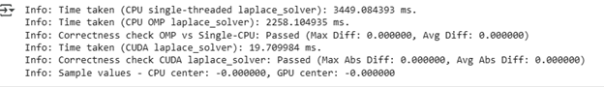  
  
Specs: Again for specs Google colab T4 TPU is used.